Section 5.1 - Functions as Rules and Tables

A function is a rule relating two or more variables.

The variable(s) used as input into the function is called the _____________ variable(s)

The variable that we get as output is called the _____________ variable

For a function relating the number of miles driven, m, and the total amount of gas consumed, g, which makes sense to be the independent variable, and which should be the dependent variable?

To talk about a function, we give it a name. We usually start with f, and we specify the input to the function by putting it in parentheses.

For instance, with an independent variable of x, and a dependent variable of y, we have:
f(x) -- pronounced 'f of x'

We can refer interchangeably to the output of the function as f(x) or y, so we might say y = f(x)

Suppose we have a function f(x) = 2x + 8
We can change the name of the input variable by substituting: f(w) = 2w + 8
And we can also evaluate it the same way: f(5) = 2(5) + 8

Fill in the table
x | f(x)
0

1

2

3

The values of the independent variable that the function can handle are called the ___________

The values of the dependent variable that can be achieved as output are called the ___________

What are the domain and range of the function f(x) = 2x + 8? (hint, consider the graph)

Suppose f(x) = 2x + 8 represents the total cost to go on x rides during a carnival. What is the meaning of 2 and the 8 in the question?

What is the domain?

What is the range?

Consider the fuction h(t) that models the height of a bouncy-ball above the ground t seconds after it is dropped from an initial height, . Sketch a graph of h(t).

What is the domain?

What is the range?
Interval notation
To describe a portion of the real numbers, we can use inequalities, like , but this only makes sense for x. Alternately we can use interval notation, which specifies the left endpoint and the right endpoint of the interval, and whether or not they are included.

When the endpoint is included, our graph uses a closed (filled in) circle, and the interval notation uses a bracket

[3, 9]

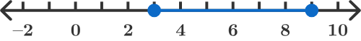
When the endpoint is not included, we graph an open circle (not filled in), and the interval notation uses a parenthesis. Be careful not to confuse this with an ordered pair (point)
-1 < x < 4
(1, 4)
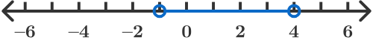
You can mix-and-match these, but the left endpoint is always written first. What is the interval notation here?

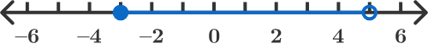

Shading to infinity can be done using either −∞ or ∞. What is the interval notation?

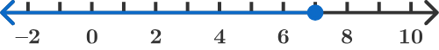

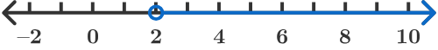

Write a function rule for the table:
Number of CDs | 2 | 5 | 6 | 8 | 11
Cost($) | 4 | 10 | 12 | 16 | 22

Write a function rule for the table
x | -10 | -7 | 0 | 3 | 7
y | 10 | 7 | 0 | 3 | 7

Alfredo wants a deck build around his pool. The dimensions of the pool are 12 f eet ×24 f eet. He does not want to spend more than a set amount and the decking costs $3 per square foot.

Write the cost of the deck as a function of the width of the deck
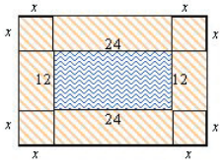

Functions don't need to have an easy equation behind them
x | 1 | 5 | 2 | 3 | 4
y = f(x) | 4 | 4 | 2 | 4 | 1
What is f(3)?

They do need to not be ambiguous, though
x | 1 | 2 | 1 | 2 | 1
y = f(x) | 3 | 4 | 5 | 6 | 7
What is f(1)?
Section 5.2 - Functions as Graphs
Graph the function that has the following table of values
x | -2 | -1 | 0 | 1 | 2
y | 6 | 8 | 10 | 12 | 14
We are not told the domain or range, so we will need to make an assumption

Graph the function that has the following table of values
side of square | 0 | 1 | 2 | 3 | 4
area of square | 0 | 1 | 4 | 9 | 16
What domain and range make sense here?
Graph the function that has the following table of values
Number of baloons | 12 | 13 | 14 | 15 | 16
Cost | 41 | 44 | 47 | 50 | 53
What domain and range make sense?

Graph f(x) = | x - 2 |

What is the doman and range?
Graph
What is the domain and range?

When we have a relation between independent and dependent variables, we're not guaranteed that we have a function.

In a function, for each input there is exactly one output

Determine if the relation is a function:
a) (1, 3), (-1, -2), (3, 5), (2, 5), (3, 4)

b) (-3, 20), (-5, 25), (-3, 5), (7, 12), (9, 2)

c)
x | 2 | 4 | 6 | 8 | 10
y | 41 | 44 | 47 | 50 | 53

d)
x | 2 | 1 | 0 | 1 | 2
y | 12 | 10 | 8 | 6 | 4

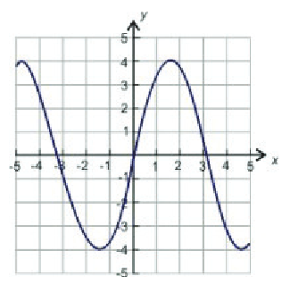
e) f)

Vertical line test:
If you can draw a vertical line that passes through a graph in more than one place, the relation is not a function.

Examples: Parabola, circle, sideways parabola

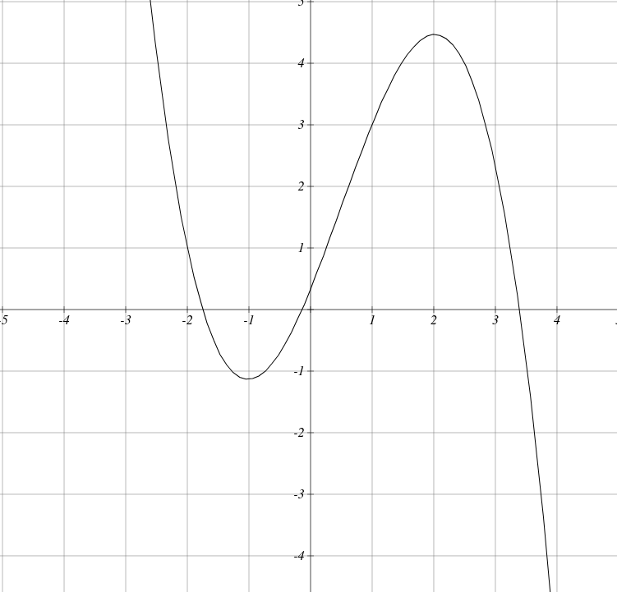
What is the domain and range?

Find f(1)

Find f(-1)

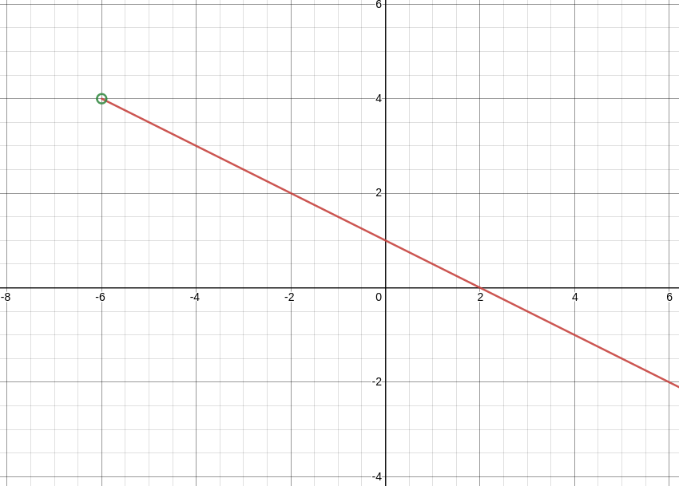
What is the domain and range?
Section 5.3 - Linear Function Graphs

If we have a graph that is a line, what must be true in order for it to be a function?

Rewrite the following equations so that y is a function of x and written f(x)

a) y = 2x + 5

b) y = -0.2x + 7

c) x = 4y - 5

d) 9x + 3y = 6
A function f is defined . Evaluate the following:
a) f(2)

b) f(-1)

c) f(0)

d) f(t)

A function g is defined . Evaluate the following
a) g(2)

b) g(0)

c) g(-1)

d) g(-2)

e) g(t)

Recall that and .

Find

Arithmetic Progression
Find the pattern
x | 0 | 1 | 2 | 3 | 4
f(x) | 3 | 5 | 7 | 9 | 11

Adding a set number every time is called an arithmetic progression. There is a common difference, as in the difference (using subtraction) that is in common (shared by all of them).

Find the common difference for the following sequences
7, 11, 15, 19

12, 1, -10, -21

Arithmetic sequences are discrete, while linear functions are continuous

Discrete means that the sequence has x values at distinct points (the 1st term, 2nd term, etc)
Often the domain is the Natural numbers

Continuous means that the function has values for all possible values of x over an interval.
Often, the domain is the Real numbers

